Call Center Assignment Design Document

# Database Design:

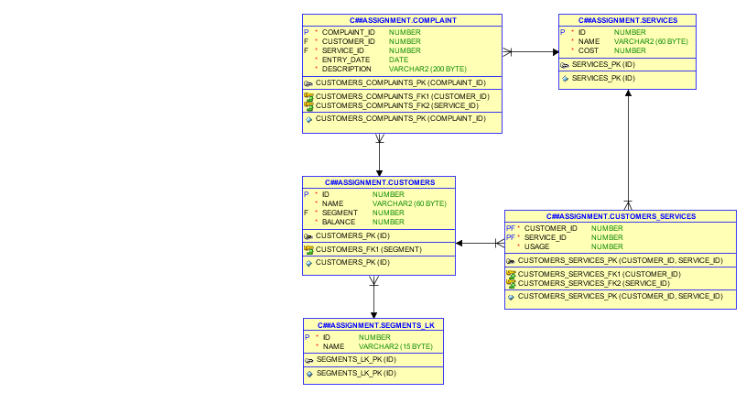

# Application Architecture:

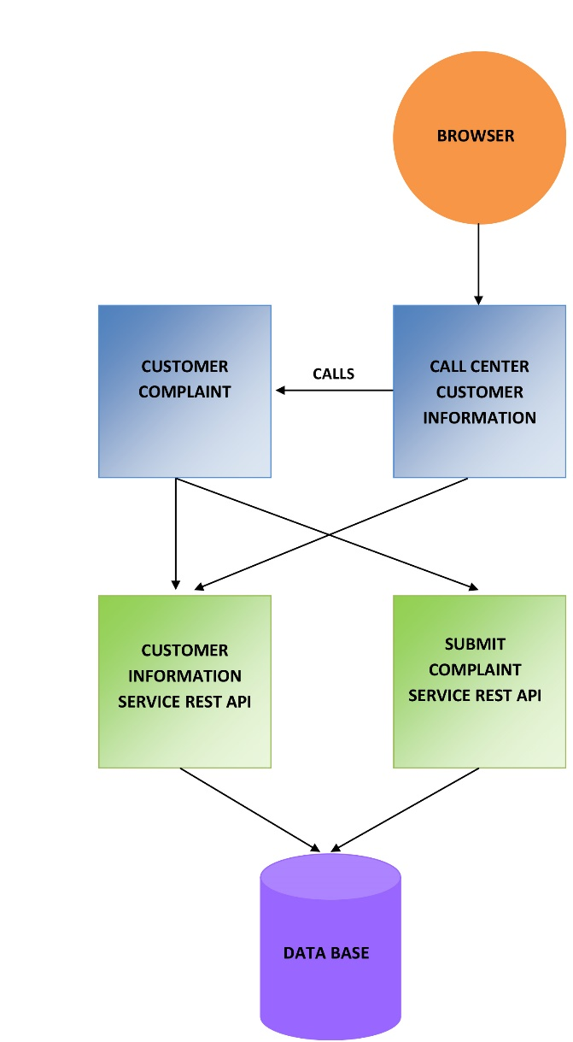

# Application Components:

## Front-end Applications:

1. Call Center Customer Information:
   1. Technology: JSF
   2. Context: path="/CallCenterCustomerInformation
   3. Application Server: apache-tomcat-9.0.6
   4. Browser used in testing : Firefox version:61.0.1 with extension: CORS Everywhere
   5. Customer Information page path : <http://localhost:8081/CallCenterCustomerInformation/customerInformation.xhtml>
   6. Configurations :
      1. Web.xml :
         1. Parameter : CustomerInformationServicURL
            1. Description: URL of customer information web service
            2. Value in file : http://localhost:8081/CustomerInformationService/retrieveCustomerInformation?customerId=
         2. Parameter : ComplaintHomePageURL
            1. Description: URL of customer complaint application home page
            2. Value in file :

http://localhost:4200/home/

* + - 1. Parameter: ComplaintSubmitPageURL
         1. Description: URL of customer complaint application submit complaint page
         2. Value in file :

<http://localhost:4200/complaint/>

* + 1. Log4j.properties

1. Customer Complaint:
   1. Technology: Angular
   2. Routes :
      1. Submit Complaint Page: <http://localhost:4200/complaint/1>
      2. Home Page: <http://localhost:4200/home>
   3. Browser used in testing : Firefox version:61.0.1 with extension: CORS Everywhere
   4. Configurations :
      1. Environment.ts :
         1. Parameter : CustomerInformationServicURL
            1. Description: URL of customer information web service
            2. Value in file : http://127.0.0.1:8081/CustomerInformationService/retrieveCustomerServices?customerId=
         2. Parameter: ComplaintSubmitServiceURL
            1. Description: URL of customer complaint submit web service
            2. Value in file :

<http://127.0.0.1:8081/SubmitComplaintService/complaints>

## Micro services:

1. Submit Complaint Service
   1. Role: This micro rest web service is responsible for the business of creation of new complaint to be used by Customer Complaint front end application.
   2. Technology: Spring MVC, Hibernate
   3. Configurations:
      1. Config.properties (inside CallCenterCommon)
         1. Include database properties
      2. Log4j.properties
2. Customer Information Service
   1. Role: This micro rest web service is responsible for the business of retrieving of customer information to be used by Customer Complaint front end application and Call center customer information application.
   2. Technology: Spring MVC, Hibernate
   3. Configurations:
      1. Config.properties (inside CallCenterCommon)
         1. Include database properties
      2. Log4j.properties

## Common Projects:

1. CallCenterCommon:
   1. Include database entities and configuration for hibernate session factory and data source beans.
2. CallCenterDto:
   1. Include the dto models used in project.